Hashing Lab

Ryan Coon

CYB-505

Professor Devin Ogg

August 7, 2024

Part 1:

Screenshots:



MD5 Hash created on file Coon in Kali Linux.



Sha256 Hash created on file Coon on Kali Linux.

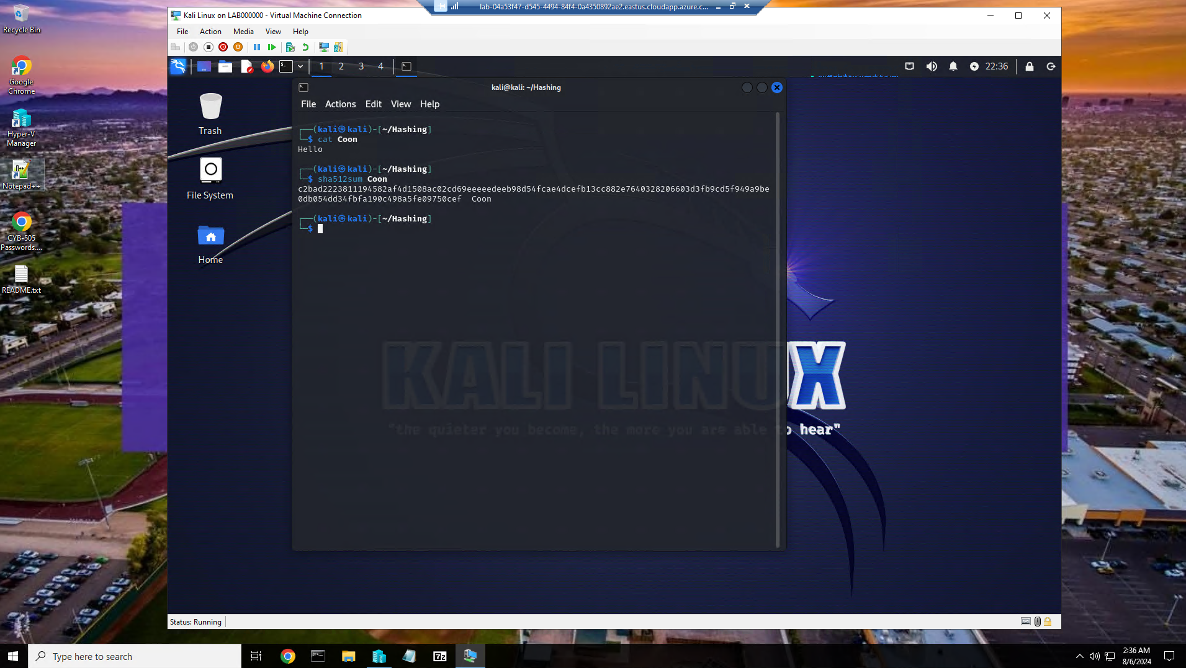

Sha512 Hash created on file Coon on Kali Linux.



MD5 Hash created on file Coon.txt on Windows 10



Sha256 Hash created on file Coon.txt on Windows 10\



Sha512 Hash created on file Coon.txt on Windows 10

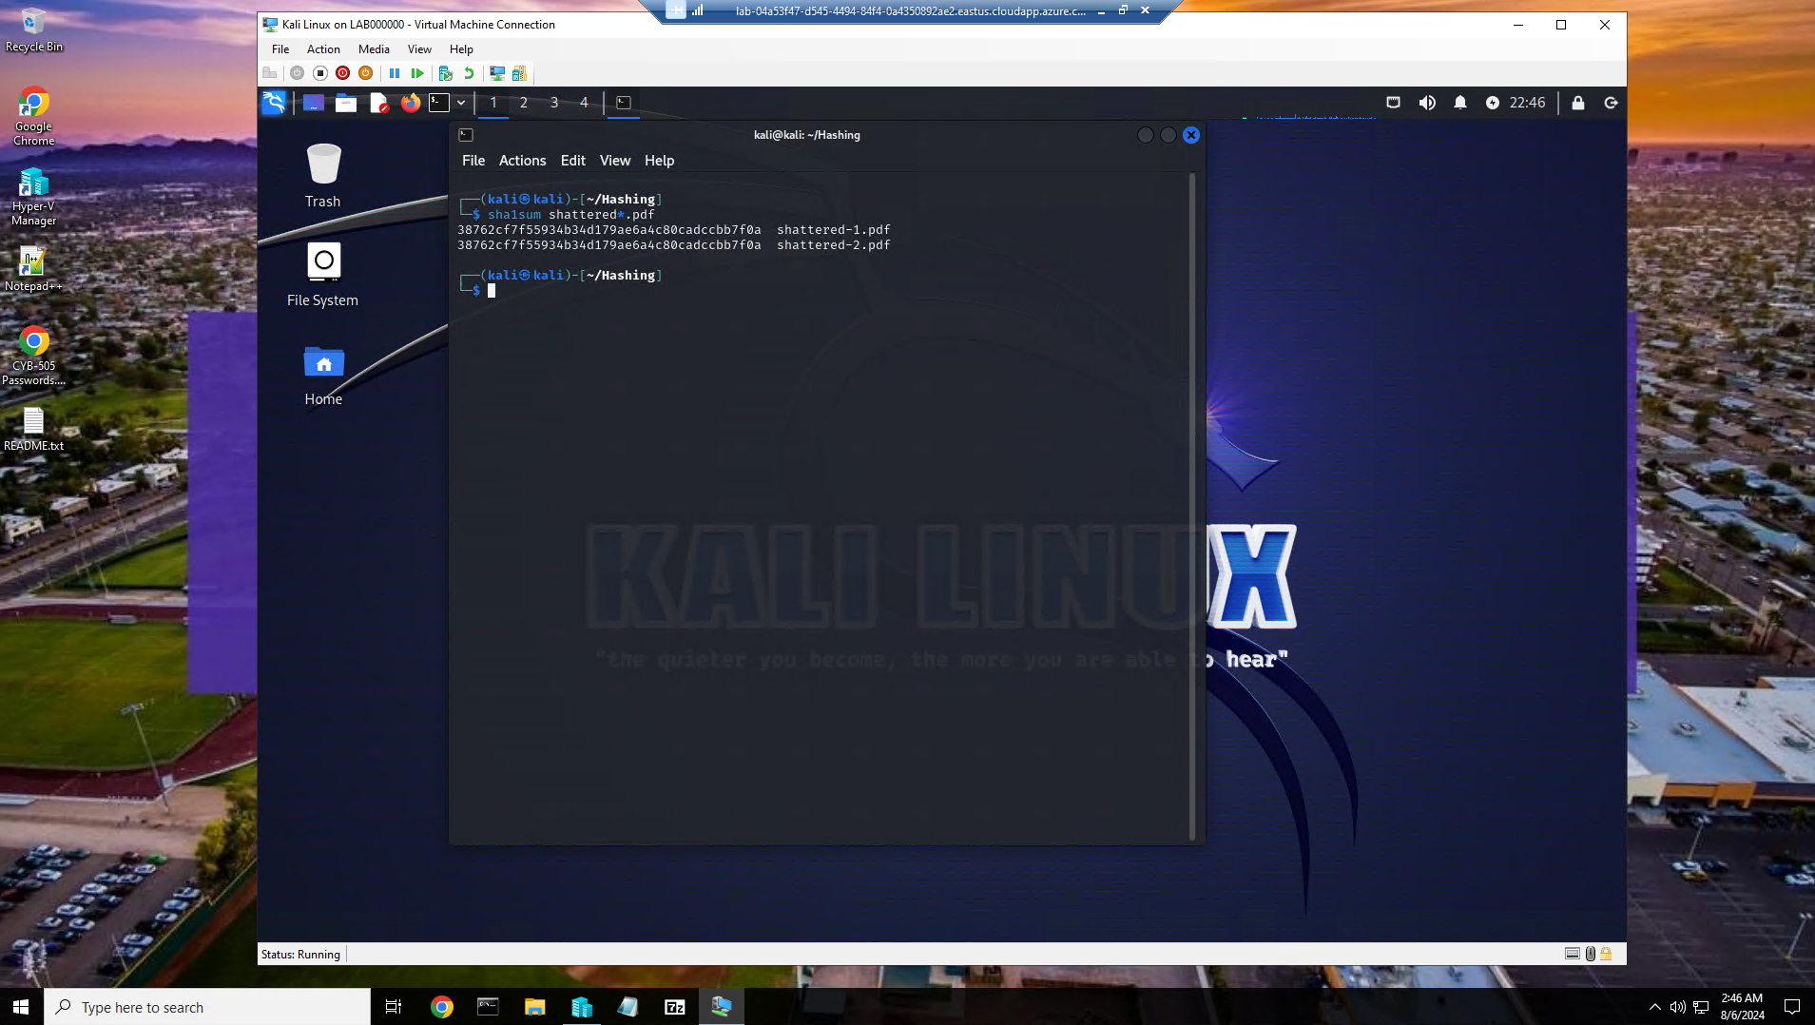

Hash collision example produced using Sha1 hash.

Part 2:

**Describe symmetric and asymmetric encryption and provide examples.**

Symmetric encryption uses the same key for both encryption and decryption of data. This means that the sender and the recipient must both have access to the same secret key.

Asymmetric encryption uses a pair of keys - a public key for encryption and a private key for decryption. This allows for secure communication between parties without the need to share a secret key.

Examples:

AES (Advanced Encryption Standard) is a widely used symmetric encryption algorithm in applications like secure communication, file encryption, and data protection.

RSA (Rivest-Shamir-Adleman) is a common asymmetric encryption algorithm used for secure data transmission, digital signatures, and key exchange in various cryptographic protocols.

**Explain why hashing or message digest is important.**

Data Integrity - Hashing ensures data integrity by generating a unique fixed-size hash value from the input data. Any change in the input data will result in a different hash value, allowing for easy detection of tampering or corruption.

Data Authentication - Hashing can be used to verify the authenticity of data. By comparing hash values, recipients can ensure that the data has not been altered during transmission.

Password Security - Hashing is commonly used to securely store passwords. Instead of storing actual passwords, systems store hashed versions of passwords. When a user logs in, the system hashes the entered password and compares it to the stored hash for authentication.

Digital Signatures - Hashing is a key component of digital signatures. By hashing a message and encrypting the hash with a private key, digital signatures provide a way to verify the integrity and authenticity of a message.

Efficient Data Retrieval - Hashing is used in various data structures like hash tables to facilitate quick data retrieval based on keys. This allows for efficient storage and retrieval of information in databases and systems.

**Describe what a collision is and how it affects hashing.**

In the context of hashing, a collision occurs when two different inputs produce the same hash output. This means that two distinct sets of data result in the same hash value. Collisions in hashing can have significant implications for data integrity, security, performance, and the reliability of hash functions. Hash functions are designed to minimize the likelihood of collisions to maintain the integrity and security of data processing and storage systems.

**Explain what the difference is between the MD5, SHA256 and SHA512 hashing algorithms, and why might you want to use one over the other.**

MD5 produces a 128-bit hash value. MD5 is commonly used in non-cryptographic scenarios like checksums and integrity verification where security is not a primary concern.

SHA-256 generates a 256-bit hash value. SHA-256 hash is widely used in cryptographic applications like digital signatures, SSL certificates, and blockchain technology.

SHA-512 produces a 512-bit hash value. SHA-512 is commonly used in scenarios that require high-security standards, such as government and military applications.

The choice between MD5, SHA-256, and SHA-512 depends on the specific security needs, performance considerations, and compatibility requirements of the application or system where the hashing algorithm will be implemented. For higher security and resistance to attacks, SHA-256 and SHA-512 are generally preferred over MD5.

**Explain PKI and data security and describe what role cryptography plays in PKI. Identify some common uses for the technology and how it is important in keeping information secure.**

Public Key Infrastructure (PKI) is a system of policies, processes, and technologies used to manage digital keys and certificates for secure communication over networks. It plays a crucial role in ensuring data security through the use of cryptography.

Some common uses for PKI are:

Secure Communication - PKI is used to create secure channels for data transmission, such as secure email communication and secure online transactions.

Digital Signatures - PKI enables the use of digital signatures to sign documents, contracts, and transactions electronically, ensuring their authenticity and integrity.

Certificate Authorities (CAs): - PKI relies on CAs to issue and manage digital certificates that bind public keys to entities, enabling trust in secure communications.

Virtual Private Networks (VPNs) - PKI secures VPN connections by authenticating users and encrypting data transmissions over public networks.

**Compare authentication, authorization, and nonrepudiation.**

Authentication verifies identities, authorization controls access based on those identities, and non-repudiation ensures accountability by preventing denial of actions in electronic communications. These concepts work together to maintain security, integrity, and trust in information systems and transactions.

**References:**

Chung, C. (2019). *Introduction to Hashing and its uses*. 2brightsparks.com. https://www.2brightsparks.com/resources/articles/introduction-to-hashing-and-its-uses.html

*Exploring Cryptography, Encryption, and Data Security: A Comprehensive Guide*. (2024, April 4). Lansweeper. https://www.lansweeper.com/blog/cybersecurity/exploring-cryptography-encryption-and-data-security-a-comprehensive-guide/

Freeman, J. B. (2020, November 18). *Hash Collisions Explained*. Freeman Law. https://freemanlaw.com/hash-collisions-explained/

Gee, T. (2020, March 22). *Authentication, Authorization, Accounting & Non-Repudiation | CompTIA IT Fundamentals FC0-U61 | 6.4*. Technology Gee. https://www.technologygee.com/authentication-authorization-accounting-non-repudiation-concepts-comptia-it-fundamentals-fc0-u61-6-4/

GeeksForGeeks. (2019, June 6). *Difference between Authentication and Authorization - GeeksforGeeks*. GeeksforGeeks. https://www.geeksforgeeks.org/difference-between-authentication-and-authorization/

*How is a PKI Useful for Network Security?* (n.d.). Portnox. https://www.portnox.com/cybersecurity-101/public-key-infrastructure-pki/

ip_admin. (2023, February 14). *Symmetric Encryption vs Asymmetric Encryption: How it Works and Why it’s Used*. Device Authority. https://deviceauthority.com/symmetric-encryption-vs-asymmetric-encryption/

Lowery, J. (2020, March 26). *MD5 vs SHA-1 vs SHA-2 - Which is the Most Secure Encryption Hash and How to Check Them*. FreeCodeCamp.org. https://www.freecodecamp.org/news/md5-vs-sha-1-vs-sha-2-which-is-the-most-secure-encryption-hash-and-how-to-check-them/

Stec, A. (2022, January 15). *MD5 vs. SHA Algorithms | Baeldung on Computer Science*. Www.baeldung.com. https://www.baeldung.com/cs/md5-vs-sha-algorithms

*What is PKI? A Public Key Infrastructure Definitive Guide*. (n.d.). Keyfactor. https://www.keyfactor.com/education-center/what-is-pki/